Object oriented programming
LAB FILE

NAME – VANSH MADAAN
BATCH- B4
SAP_ID- 500123857
ROLL_NO - R2142230412
1. Explore and understand the role of JDK, JRE and JVM.

JVM (Java Virtual Machine)
Role: It is responsible for executing Java programs by converting Java bytecode into machine-specific code.
Key Features:
- Converts Java bytecode to native machine code (Interpreter & JIT Compiler).
- Manages memory (Garbage Collection). - Provides runtime environment for Java applications.
- JVM alone cannot compile Java programs—it only runs them.

JRE (Java Runtime Environment)
Role: JRE provides the necessary libraries and environment to run Java applications but does not contain the compiler.
- JVM (to execute Java bytecode).
- Core libraries (e.g., java.lang , java.util ).
- Support files for execution.

JDK (Java Development Kit)
Role: JDK is required for developing, compiling, and running Java applications. It includes everything in JRE plus development tools.
- JRE (to run Java programs).
- JVM (to execute Java bytecode).
- Java Compiler ( javac ) (to convert .java files to .class bytecode).
- Development tools (Debugger, Javadoc, Jar utility, etc.).
2. Install the latest available JDK and verify the Java environment.
Step 1: Download and Install the Latest Oracle JDK
- Visit the Official Oracle JDK Website:
- Go to the official website for Oracle JDK:
Oracle JDK Downloads
(Note: Ensure you're downloading the correct version suitable for your OS, e.g., JDK 17 or JDK 16).
- Download the JDK:
- Select the appropriate platform (Windows, macOS, or Linux).
- Accept the license agreement and download the installer for your system.
- Install the JDK:
- Run the downloaded installer.
- Follow the installation steps and take note of the installation path (default is usually something like C:\Program Files\Java\jdk-15 on Windows).
Step 2: Set Up the Java Environment
1. Set JAVA_HOME Environment Variable:
○ Windows:
■ Right-click on This PC → Properties → Advanced system settings → Environment Variables.
■ Under System Variables, click New and add:
■ Variable Name: JAVA_HOME
■ Variable Value: The JDK installation path, e.g., C:\Program Files\Java\jdk-15 .
Set Path Variable :
● Windows :
○ In the Environment Variables window, find the Path variable under System Variables and add the following: Bash
○ C:\Program Files\Java\jdk-15\bin
Step 3: Install Visual Studio Code (VSCode)
Step 4: Install Java Extension Pack for VSCode
Step 6: Verify Java Environment in VSCode
- Create a sample hello world program using a simple text editor and show the steps to compile and execute the program using command prompt.
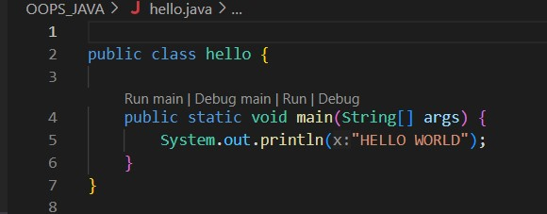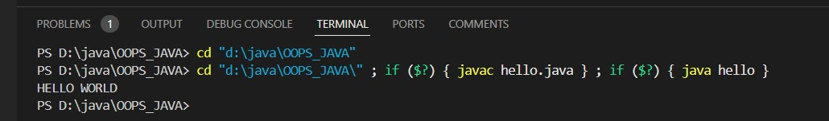
- Display your name and complete address in different lines.
